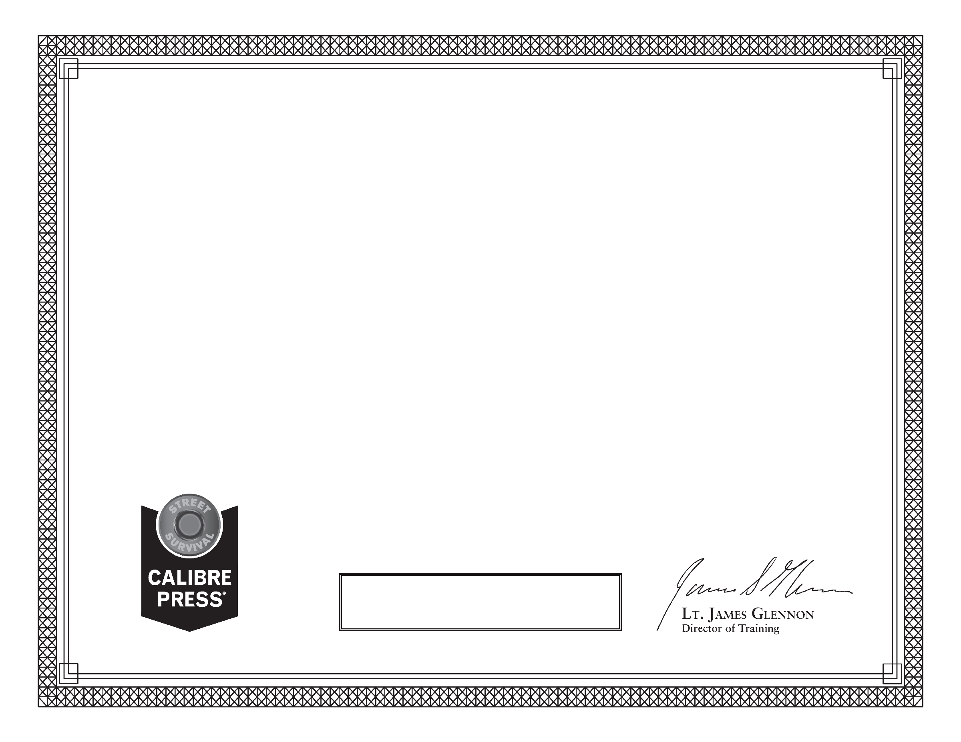

For successfully completing the course

PRESSURIZE PEOPLE:

*Recognize & Implementing Force Mitigation Opportunities*

2.5 hours of Instruction

Calibre Press  
This certificate is presented to:

Name